The General-Purpose Register (GPR-Register)

A CPU register is build of digital logic circuits. A CPU register can be used to store data. Its extremly fast and reading or writing data to a register is way faster than to a memory address.

If we want to read or write data from RAM for example then the data needs to go over a bus from the RAM to the CPU and that costs time. A bus is something like a physical wire that is used to transfer data from A to B or from B to A.

But the size of data that we can save in CPU register is pretty limited.

Register Purpose Explanation
RAX Accumulator Used for arithmetic results and function return values.
RBX Base Functions will not change the value of this register.
RCX Counter Used for counting operations like REP or LOOP.
RDX Data Its holding the high order bits in multiplications and
divisons. Its also used in register pairing (RDX:RAX)

RSI Source index Used as a source register for string operations.
RDI Destination index Used as a destination register for string operations.

RBP Base pointer (stack frame) Base of the current stack frame. That is used to
reference local variables.

RSP Stack pointer This points to the top of the stack.
R8 General purpose
R9 General purpose
R10 General purpose
R11 General purpose
R12 General purpose
R13 General purpose
R14 General purpose
R15 General purpose

These registers will become very important when we talk about API calls:
RDI, RSI, RDX, RCX, R8, R9

64 Bit 32 Bit 16 Bit 8 bit high-part 8 Bit low-part
RAX EAX AX AH AL
RBX EBX BX BH BL
RCX ECX CX CH CL
RDX EDX DX DH DL
RSI ESI SI - SIL
RDI EDI DI - DIL
RBP EBP BP - BPL
RSP ESP SP - SPL
R8 R8D R8W - R8B
R9 R9D R9W - R9B
R10 R10D R10W - R10B
R11 R11D R11W - R11B
R12 R12D R12W - R12B
R13 R13D R13W - R13B
R14 R14D R14W - R14B
R15 R15D R15W - R15B

EAX, AX, AL and AH are inside of RAX.
Example:
64 Bit
RAX: 0000000000000000

EAX
RAX: 0000000000000000
The blue area is the high part of RAX and the green part is the low part of RAX.

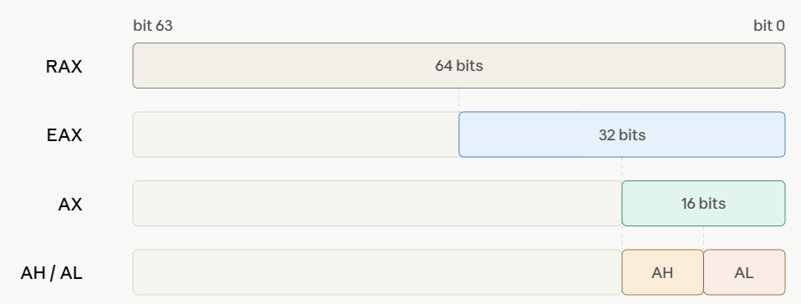

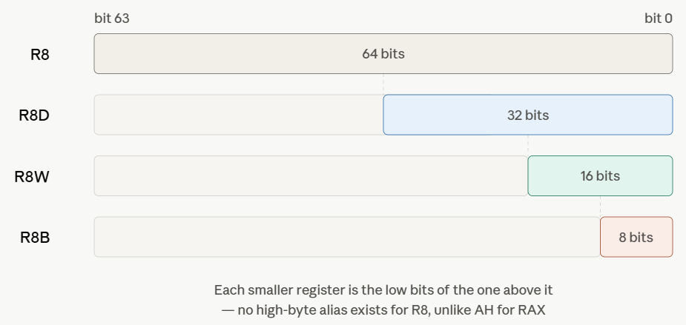

Exercise
Where is AX?
RAX: 0000000000000000
Where is AH?
RAX: 0000000000000000
Where is AL?
RAX: 0000000000000000

Hint:
RAX: 0000000000000000
Each colored number represents 1 byte. (1 byte = 8 bit). It doesn’t matter if a colored value is 00 or ff both values have a size of 1 byte.
At the end of the video I will show the solution.

The RFLAG Register
The RFLAG register is a 64 bit register that records the outcome of a logical or arithmetic operation.
These are the most important bit flags for us:

ZF = Zero Flag
OF = Overflow Flag
CF = Carry Flag
SF = Sign Flag
DI = Direction Flag

Later in the course I will explain how to use the 5 most important flags.

Example for a logical operation:
rbx = 1
rcx = 1
cmp rbx, rcx

cmp means compare. It compares if rbx holds the same value as rcx.
If both register hold the same value then the ZF (zero flag) register gets the value 1 otherwise ZF gets the value 0.

Example for a arithmetic operation:

rbx = 1
rcx = 6
sub rbx, rcx
sub means subtract. In this case it subtracts the value in rbx from the value in rcx.
1 – 6 = -5
If the result of the substraction is negative then the SF (sign flag) gets the value 1. If the result of the substraction is positive then the SF flag gets the value 0.

A flag overview from AMD:
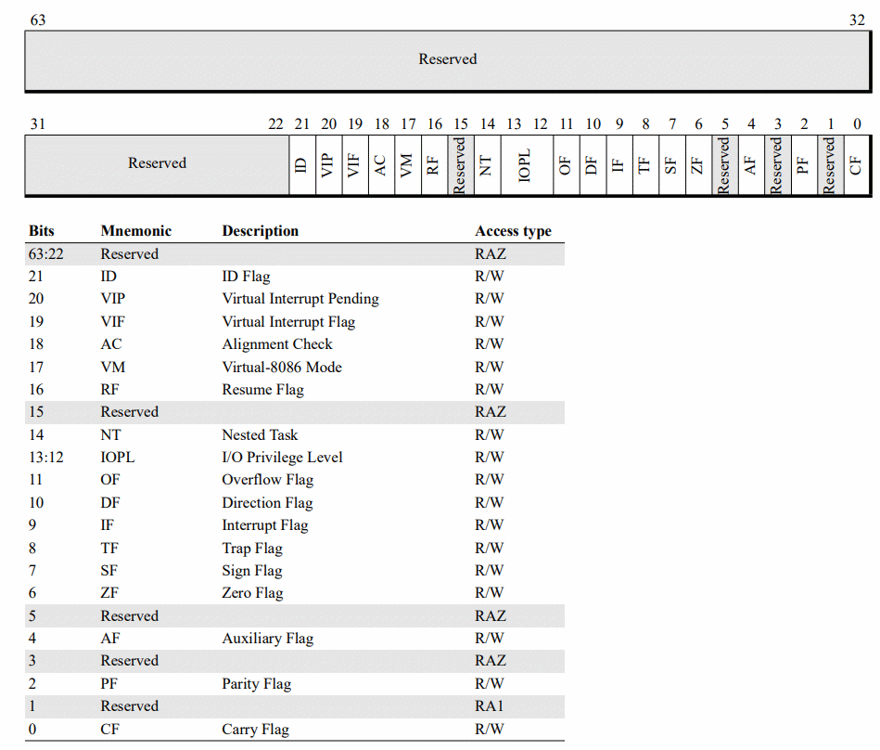

More informations about the flags can be found here:

AMD64 Architecture Programmer's Manual Volume 1: Application Programming:
Page: 70
https://docs.amd.com/v/u/en-US/24592_3.24

AMD64 Architecture Programmer's Manual Volume 2: System Programming
Page: 52
https://docs.amd.com/v/u/en-US/24593_3.44_APM_Vol2

More register:

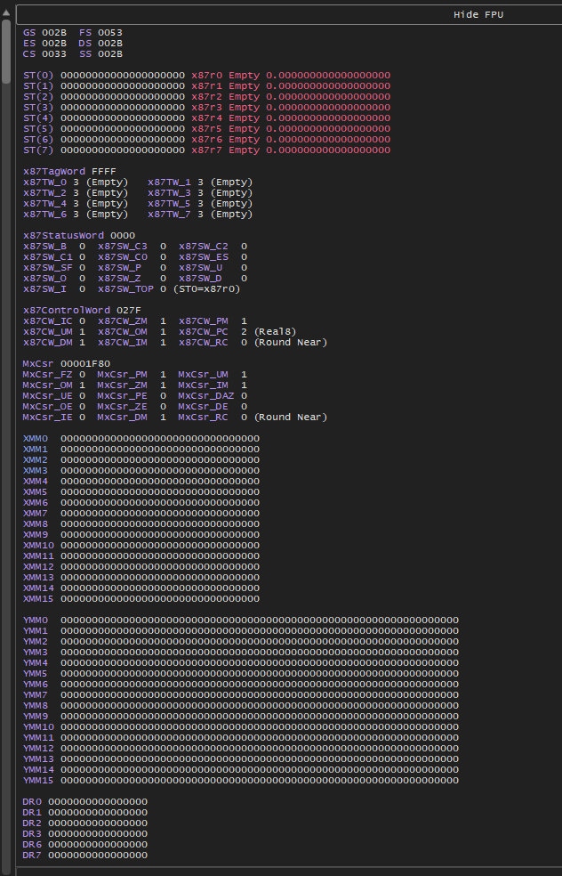

Solution to the excercises:

Where is AX?
AX
RAX: 0000000000000000

Where is AH and where is AL?
AHAL
RAX: 0000000000000000

